Two world leading research reactors join forces to create dual supply of medical isotope iodine-125
Nuclear Research & Consultancy Group (NRG) and McMaster University’s Nuclear Reactor (MNR) have teamed up to advance customer service to a new level

BARCELONA, Spain, 15th October 2019 – McMaster University’s Nuclear Reactor (CAN) and NRG (NL) announced a unique collaboration between the Netherlands and Canada in the field of nuclear medicine.

Working together, these two globally renowned research reactors will provide the world with the highest quality radioiodine (I-125), used for the treatment of prostate and other various types of cancers, at the highest level of reliability.

The importance of readily available medical isotopes
An estimated 80% of people who suffer cancer at any times in their lives will receive some form of radiotherapy. This emphasizes the need for the availability of these treatments, which also reflects on the availability of a particular isotope in the case of brachytherapy. Prof. Dr. Coen Rasch, Radiologist-Oncologist at LUMC in Leiden in the Netherlands and Chairman of the Dutch Society for Radiotherapy and Oncology (NVRO) states: “This is of utmost importance. The shortage of isotopes a couple of years ago clearly showed the vulnerability of a system which relies on only a few manufacturers worldwide. The field of short-running isotopes like I-125 is the first to suffer in such a situation.”

Prostate cancer is one of the most common cancers in men worldwide. Brachytherapy with iodine-125 (I-125), a radioactive isotope, is an established treatment and yields good results for treating patients with this cancer at an early stage. Access to I-125, was in great danger in 2017 as one of the I-125 producing reactors unexpectedly shut down. A worldwide shortage of the product required an acute and sustainable emergency solution. Canada and The Netherlands responded with their new collaboration.

Chris Heysel, Director of Nuclear Operations and Facilities at McMaster University in Hamilton, Canada, says discussions around the potential collaboration -- specifically regarding the manufacturing and supply of I-125 – were escalated by the major global shortage of the life-saving treatement. “With one of the three major suppliers ceasing its production of I-125, and the subsequent shutdown of another research reactor, we recognized that, together, we could address the shortage crisis and ensure a steady supply of this life-saving treatment. NRG also saw the impact to patients and our collaboration began. We immediately started a focussed assessment of the safety, technical and regulatory requirements needed to bring the project to fruition.”

Dual supply provides high quality and high reliablity
Within the medical isotope community, it is critical that the end user, the patient, receives the highest level of supply reliability. Thus, seed manufacturers and pharmaceutical companies have turned towards a dual supply set-up. Heysel emphasizes the importance of having two reactor based suppliers of I-125: “Reactors are like machines, so they need regular maintenance. What we offer as a team is that we can guarantee a constant, reliable supply of I-125. The end product derived from either reactor is identical and the health care industry consistently receives a very high quality product.” Heysel continues: “The arrangement between NRG and MNR will provide our clients with ‘one-stop-shopping’ access to the dual supply they require. Our reputations – along with our ability to work seamlessly and collaboratively – position us perfectly to lead in this global healthcare space.”

Looking forward
Based on the reputations of both organizations, it is clear that together MNR and NRG represent a strong team, and the most reliable supply chain of I-125 in the world. NRG and MNR share a dedicated and patient-focussed approach to operations; it drives them, not only towards reliability of supply but also to ensuring the highest level of quality for the patient. Prof. Dr. Coen Rasch, LUMC, the Netherlands summarises: “Collaboration between consortia such as Nuclear Research and consultancy Group (NRG) in the Netherlands and McMaster University’s Nuclear Reactor in Canada to strengthen the system is good, as there is worldwide demand for reliable supply.”

Production is set to begin in Spring 2020.

The role of I-125 in cancer treatment
- I-125 is a radioisotope of iodine
- A liquid (aqueous) solution of I-125 is fixed to a substrate
- This is encapsulated in so-called small titanium ‘seeds’ (about the size of a grain of rice)
- These seeds can be located exactly around the tumour: this is also known as brachytherapy

Collaboration MNR (Canada) and NRG (The Netherlands)
The MNR and NRG collaboration will offer dual supply of high quality I-125 for use in brachytherapy. By joining forces they will provide a single point of contact for seamless and uninterruptable supply. The resulting highest quality in the industry will be reproducible and provides an effective and controlled therapy to physicians around the world. Both are trusted health and nuclear partners and highly value a dedicated and customer focussed service for a long term supply commitment.

– End –

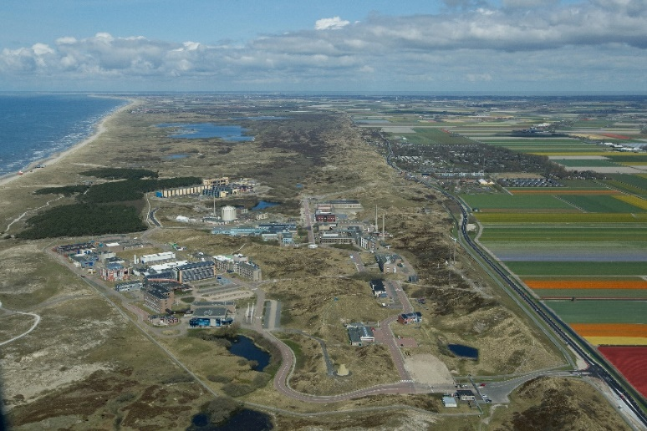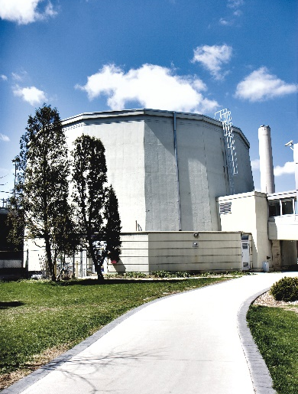
NRG site in Petten, Netherlands McMaster University’s Nucelar Reactor, Canada

More about McMaster University
Located in Hamilton, Ontario Canada, McMaster is Canada’s nuclear university. The McMaster University campus houses a world class suite of nuclear research facilities anchored by the McMaster Nuclear Reactor (MNR) – a multi-purpose research resource that provides neutrons for medical isotope production and scientific research. McMaster University’s nuclear research facilities enable discoveries in medicine, clean energy, nuclear safety, materials and environmental science, and are operated by the Nuclear Operations & Facilities unit. Learn more at nuclear.mcmaster.ca.

More about NRG
The production of medical isotopes is the primary activity of the reactor in Petten, which is managed by NRG. NRG is a global market leader in the production of medical isotopes. It strives for the development of new applications of medical isotopes used to treat life-threatening diseases. NRG performs this ambition in collaboration with UMCs and pharmaceutical companies. NRG is an internationally operating nuclear service provider. It conducts nuclear technological research, is a consultant for the safety and reliability of nuclear plants and provides services in the field of radiation protection. It also conducts research for governments aimed at developing knowledge about nuclear technology. NRG operates the High Flux Reactor owned by the European Union. All of NRG’s almost 700 employees possess expert knowledge and work in a highly innovative way. The company works for and with partners in the health sector, the energy market, the industrial sector, government and the science sector.

NRG Advancing Nuclear Medicine
Advancing Nuclear Medicine is an initiative of NRG and its partners. In Advancing Nuclear Medicine, partners from the academic world and industry are working together on spectacular breakthroughs in the treatment of life-threatening diseases by using specific radiopharmaceuticals and medical appliances in a personalised approach.
For more information, see: www.advancingnuclearmedicine.com

Contact NRG Contact McMaster University
Cora Blankendaal Michelle Donovan
NRG Press Officer McMaster University Manager, Media Relations
The Netherlands Canada
Tel. +31 6 101 16 723, Tel. +1 905-525-9140, ext. 22869
pers@nrg.eu. donovam@mcmaster.ca

