TITLE of paper
(ARIAL, 14 pt, all caps)

A.B. AUTHOR, C.D. AUTHOR (12 pt, all caps)
Department, Organisation (10 pt, italics)
Street, Postal Code City – Country (10 pt, italics)

E.F. AUTHOR
Other department, Other organisation (10 pt, italics)
Street, Postal Code City – Country (10 pt, italics)

ABSTRACT

Your manuscript must be in English. Please use UK spelling. It should start with a short abstract of 150 words maximum describing the key elements of your contribution and its conclusions. The text should be typeset in block mode. Typeface throughout the text is Arial. For this paragraph the font size is 10 pt, with left and right indents of 1.5 cm.

- Introduction (12 pt, bold)
- Settings
Your manuscript should then continue on the same page with an introduction. The typeface throughout the text is Arial. Setting of paper size is DINA4-size only. The top, left and right margins are 2.5 cm while the bottom margin is 2 cm. For all following text sections the font size is 11 pt, single line spacing with a spacing of 0 pt before and after the paragraph mark, and the lines are justified in block mode.

- Figures and tables

Figures and tables should be inserted into the text at the appropriate place. They should be clearly identified with a caption, as shown below.

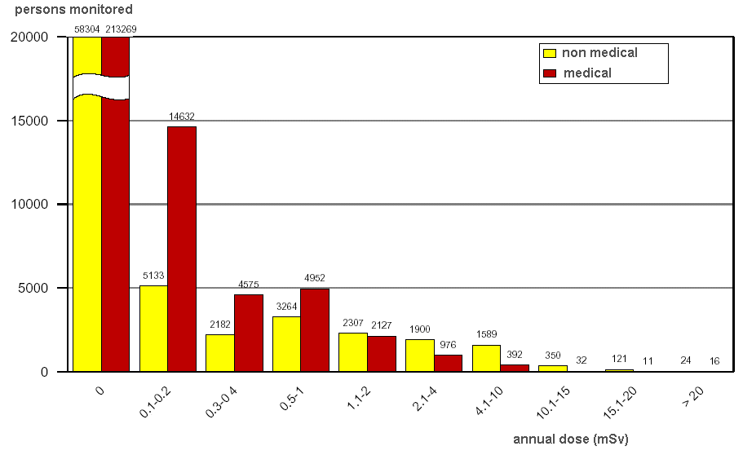
Fig 1. Caption for figure one
xxx | yyy | zzz
aaa | 123 | 456
bbb | 789 | 012
ccc | 345 | 678
ddd | 901 | 234
Tab 1: Caption for table one

- Electronic form of contribution

For the conference proceedings an electronic version as a pdf
file of your final paper is required. Please use UK spelling.

- Length of your paper

We recommend limiting your paper to five to ten pages, including the title page, all tables and figures and the references.

- Length and visual aids for oral presentations

Your presentation will be (exclusively) in English and not last more than 15 minutes.

The visual aid available to you as a speaker in an oral session is PowerPoint projection.

- Instructions for poster presentations

Posters will be on displays throughout the conference. They should be mounted on before the beginning of the first session and must be dismounted at the end of the last session. The surface available /size of the poster panels will be communicated closer to the event. At least one author per paper is requested to attend personally the whole poster session to permit proper presentation and discussion of the poster during the said poster session.

- References

Please number your references and cite them in brackets. The list of references should be at the very end of your manuscript under the section heading “References”.

- Deadline
Your full paper must be submitted by 15 March 2024 at the very latest.

Your Powerpoint presentation and CV must be in our possession by 10 April 2024 at the very latest.

- Registration

For each paper (oral or poster presentation) one author needs to be identified as presenter, register through the RRFM 2024 Online Registration System and attend the conference.

